**Make calls and Send text using Twilio in Excel**

1. Create macro enabled excel file open MS Excel, go to file> save file to local machine while saving the file in save as type dropdown select Excel macro-enabled workbook (.xlsm)

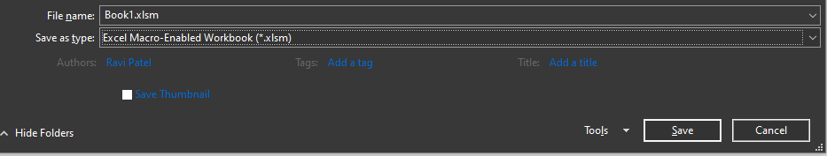

1. Extract OfficeCustomUIEditorFiles.zip from Twilio via excel root folder.
2. Run CustomUIEditor.exe from extracted folder, in app file>open and open excel file that created above.

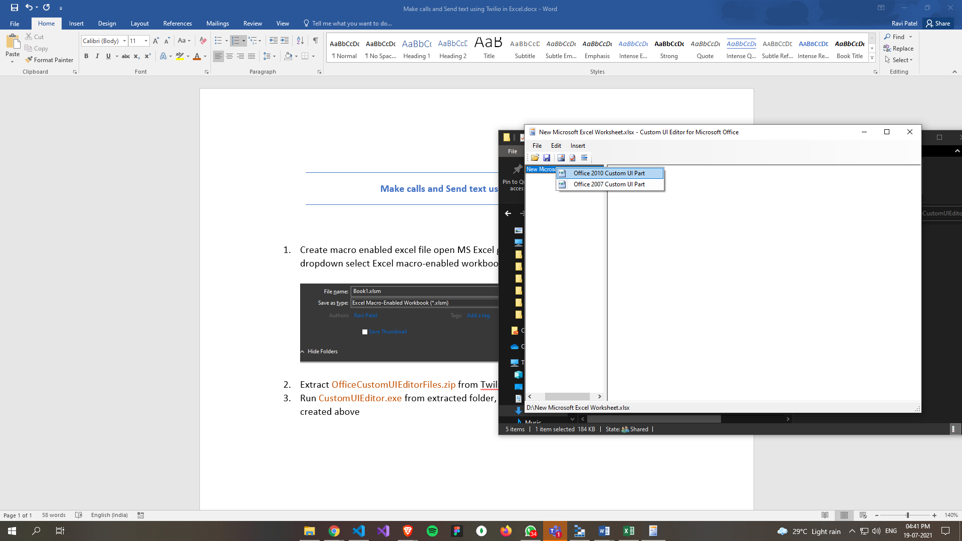

1. Right click on file from left section and select Office 2010 Custom UI Part and add below code in newly created xml file

<customUI xmlns="http://schemas.microsoft.com/office/2009/07/customui">

<ribbon>

<tabs>

<tab id="customTab" label="TWILIOSO" insertAfterMso="TabHome">

<group id="customGroup1" label="Messages">

<button id="customButton1" label="Send Message" size="large" onAction="conSendSms" image="twilioLogo" />

</group>

<group id="customGroup2" label="Call">

<button id="customButton2" label="Call" size="large" onAction="conCall" image="twilioLogo" />

</group>

</tab>

</tabs>

</ribbon>

</customUI>

In above code we are adding Custom UI buttons in Excel to call and send message, when we click any of button it triggers onAction and call that function from Excel file. To add logo right click on custom ui part and then insert icon, you can use that icon using image attribute, same as used in above code button element.

1. After adding code save and close Custom UI editor.
2. Open Excel file created above, You will be able to see new tab TWILIOSO on top.

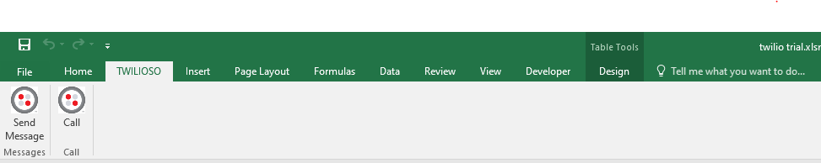

1. Go to file> option> customize ribbon in right tab enable Developer

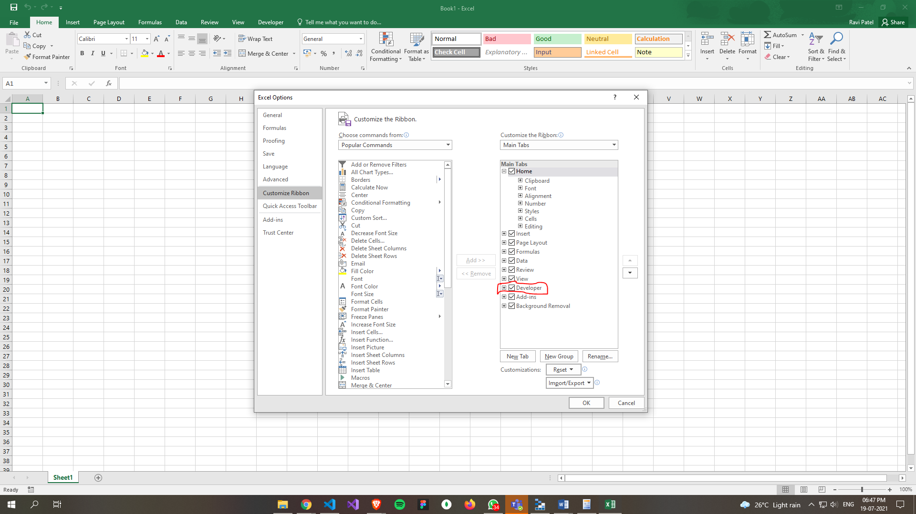

1. After enabling it click ok and you will be able to see new tab named Developer, click on that and from Developer tab open Visual Basic.

1

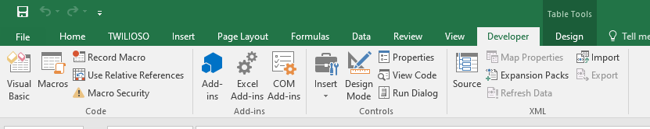

2

1. After clicking visual basic below screen will open. You need to add few module and form and connect it with Twilio tab buttons, you can do it from insert tab.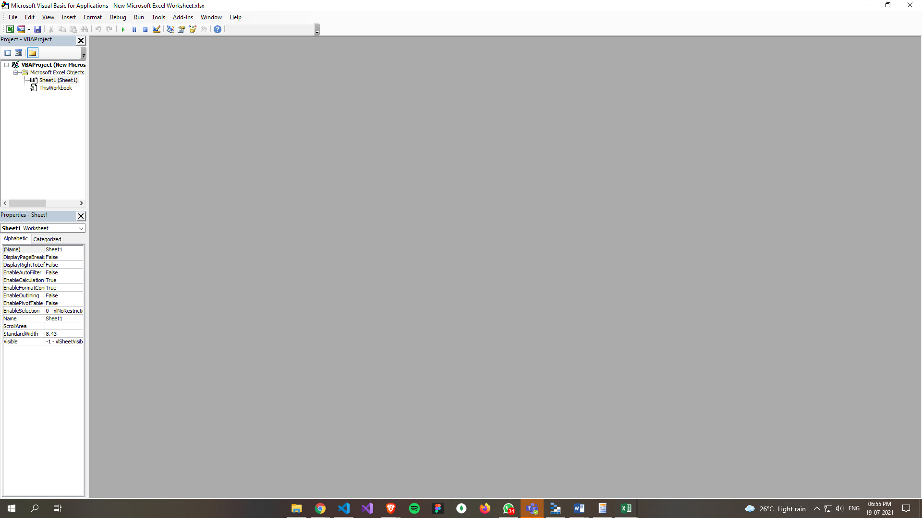
2. Create forms and module same as example excel file ( twilio trial.xlsm you can find this file with this document folder )
3. To edit form layout double click on form from forms folder in visual basic left section, to code form right click on form and select view code
4. Create same forms and module as twilio trial.xlsm file, if you open any form you will be able to see properties on left bottom section
5. You need to replace ACCOUNTSID, AUTHTOKEN AND FROMPHONE in code with your twillio account creds, Comments are there for that.
6. Save and close visual basic, now to make call and send message first you need to select cell that contains contact number and click send message or call from top TWILIOSO tab.